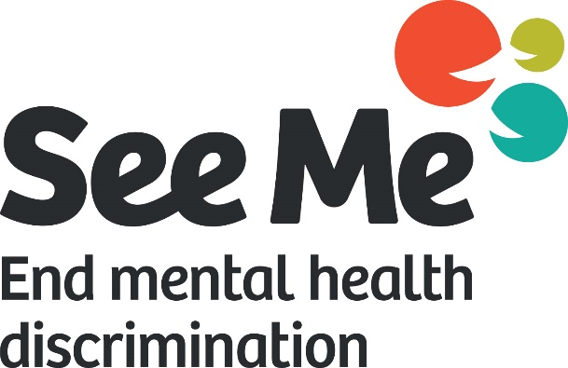

Funded Partners Annual Report

[Date]

[Partner organisation name]

Background……………………………………………….. | 3
Evaluation Plan…………………………………………... | 4
What we expected to do………………………………… | 5
Challenges………………………………………………… | 6
What we actually did…………………………………….. | 7
Reflections & Conclusions…………………………….. | 8
Appendix: Guidance…………………………………….. | 9

The partner organisation
Click or tap here to enter text.
The project
Click or tap here to enter text.
Aims and objectives
Click or tap here to enter text.
Outcomes evaluated:
1
2
3

Outcome (change or difference you want to make) | Indicators (how you know the outcome is happening) | How to collect information about the indicator | Who will do this | When and where info will be collected

Who | Click or tap here to enter text.
How | Click or tap here to enter text.
Outcomes | Click or tap here to enter text.

Who | Click or tap here to enter text.
How | Click or tap here to enter text.
Outcomes | Click or tap here to enter text.

Who | Click or tap here to enter text.
How | Click or tap here to enter text.
Outcomes | Click or tap here to enter text.

? | What about this project or your findings surprised you?
 | Click or tap here to enter text.
? | What would you do again or do more of?
 | Click or tap here to enter text.
? | What might you do differently next time or not do at all?
 | Click or tap here to enter text.
? | What will you take away with you/ what were your key learnings?
 | Click or tap here to enter text.

This template is to be used for annual reports for your See Me funded project. The guidance below provides an outline of the details that are expected in each section of the report. We encourage you to include pictures, video links and any other creative content that helps illustrate the outcomes of your project. For general guidance on how to write a report, please see X

Background
The partner organisation
Who is involved in this project?
Write a brief summary about the organisation leading this project: what is the organisation called, and what does it do? This section could also include a reminder of the overall aim of the organisation or project to set the context.
The project
What you planned to provide to deliver your outcomes
Please include a short summary of what the organisation or project agreed to do in the See Me partnership agreement, describing who you will be working with and any planned actions, activities or outputs. You might want to look back at your partnership agreement with See Me: what did you agree to do?
Aims and objectives
What are the aims, objectives and outcomes that you set out to achieve in this project?
This should include details of the planned differences or changes that you want to make for the people you work with (Outcome 1).
We have included three boxes to write a clear statement of your project outcomes. If you have fewer than three intended outcomes, you can delete any unused boxes.

Evaluation Plan
At the start of your project, you were asked to complete an evaluation plan. Please include a copy of this here, listing all intended outcomes, activities and data collection methods alongside details of who and when these activities were planned to take place. You can find evaluation plan templates and examples here on the See Me website, along with dissemination/report planning tools, and other tools to help you plan each stage of your evaluation.

 | What we expected to do | Challenges | What we actually did
Who | What goes here?  Who was on the project team? Who did you plan to work with to deliver the project? | What goes here?  Team dynamics and changes, any problems engaging with your intended population? | What goes here?  Who was on the project team at the end of the project? Did you work with the population and size of group that you set out to reach? Share your key people-related numbers & statistics (e.g. demographics/ how many people you connected with).
How | What goes here?  What were the planned project activities? What did you plan to provide or deliver? How did you plan to evaluate? | What goes here?  What didn’t go according to plan? Were there any barriers or difficulties in delivering the project? | What goes here?  Did you make any changes to the originally planned activities? Share your key activity-related numbers & statistics (e.g. how many workshops/training events etc. were delivered)
Outcomes | What goes here?  What outcomes did you set out to achieve? What were the planned differences or changes that you wanted to make for the people you work with? | What goes here?  Did any of your stated outcomes or indicators change during the project, or prove particularly difficult to evaluate | What goes here?  Detail of how you measured the project’s impact and the results of this. Overall information about the outcomes achieved What difference did you make to people you worked with? Could also include examples of how individual participants or service users experienced the projects (such as case studies or quotes).

Reflections & Conclusions
Please use the Reflections & Conclusions page to reflect on what went well, what didn’t go so well, and what you have learned from this project. The questions at the top of each section are designed to help you do this. You may want to take some time to talk to other people involved in the project to get their feedback on each question. Perhaps you could run a focus group with those involved, using the reflection questions in this section to help guide conversation.

Top tips for completing your report

