Using blogs as dissemination tool
When to use a blog
A blog can be used to publish insights, opinions and stories sharing knowledge around a specific topic or issue. Different to a full report or article, blogs are usually shorter and written in the more informal style of an opinion piece, making them engaging to a wide variety of audiences.
Blogs offer a concise discussion of a topic which as well as providing information, can also act catalyst for encouraging further engagement, encouraging people to explore more about the topic being discussed.
When disseminating evaluation outcomes, blogs are a useful way to explain the background of a project, the outcomes and why this is important, in a way that is accessible to a wider audience. They can be used as complimentary resource that can be released alongside larger evaluation reports or as valuable knowledge dissemination tool in their own right.
Blogs help to¹:
- Convey key messages
- Provide a summary of the evaluation results in an accessible way
- Present key images and graphs from a report for greater understanding
- Present different perspectives, e.g. a blog can provide views or quotes from different
stakeholders involved in the evaluation process
- Reach a wider audience
Designing a blog post
- Keep the intended audience in mind
Tailor the blog to them – the blog should be conversational and clear. Content needs to be simple and engaging and without jargon or technical terms.
- Focus on the article title
The title needs to draw the audience in and to be attention grabbing
- Make it clear and accessible
- Use subheadings, bullet point and highlighted key words to break up text and allow readers skimming the text to quickly identify key content.
- Images, quotes and graphs also can be used as text breaks and to illustrate key points.
- Hyperlinks embedded within text can be used to connect readers to external information sources.
- Provide a discussion space
Have a space for comments to allow for continuation of discussion about the ideas expressed in the blog
it is important to keep a clear structure so that the blog is easy for readers to navigate and engage with – a blog should include the following three basic elements:²

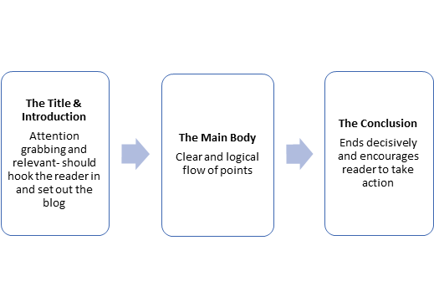
Benefits of a blog
Enable clarity | - Blogs are aimed at non-specialist audiences so they provide the chance to explain potentially complex issues and approaches in a clear and simple way
Engage a wider audience | - Transfer knowledge and findings in accessible way  - Capture wider public attention  - Allow for deeper public understanding of an issue
Timely | - Blogs can be written quickly and so can be published quickly  - They allow the creation and sharing of content to be done in real time, ensuring that the audience is able to access current and relevant information
Inspire further learning | - Engaging blog posts can open up people’s interest in an issue and act as a catalyst for further engagement and conversation about the topic covered

1. Hassnain H. Creative Communications for Evaluation Dissemination How-to Guide: Blogs. Brussels; 2020. https://europa.eu/capacity4dev/evaluation_guidelines/documents/how-guide-evaluation-blogs.
2. Balkhi S. How to Structure a Perfect Blog Post (With Examples). https://syedbalkhi.com/how-to-structure-a-perfect-blog-post-with-examples/. Published 2015.

